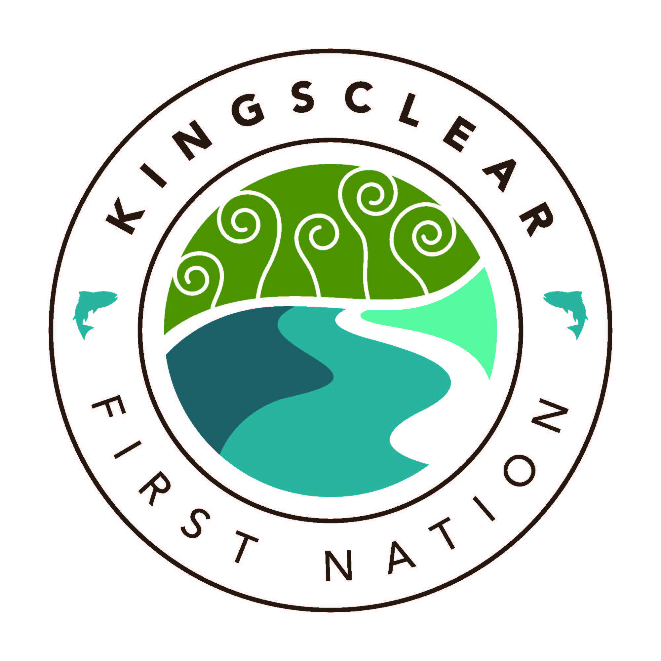 **Kingsclear First Nation**

**77 French Village Road**

**Kingsclear First Nation, NB**

**E3E-1K3**

**Tel: (506) 363-3028**

**Fax: (506) 363-4324**

[www.kingsclear.ca](http://www.kingsclear.ca)

**Job Posting**

**Position Title:** Alcohol and Drug Director

**Location:** Kingsclear First Nation, NB

**Purpose**

The Alcohol and Drug Director will provide support service to community members who request help with a personal alcohol or drug abuse problem.

**Duties and Responsibilities**

* Identify current issues in Kingsclear First Nation
* Develop and implement Kingsclear First Nation Out-Patient Program (Day Program)
* Establish a Follow-up Program for the Day Program
* Collaborate with Kingsclear’s Prevention and Mental Wellness Coordinator in the Follow-up Program
* Partner with other services to provide more opportunities for community members dealing with alcohol and drug abuse
* Collaborate with Mental Health Services
* Organize events and create and access center that surrounds alcohol and drug abuse (weekly support groups, resource library etc…)
* Preparation and maintenance of personal files/records. Ensure records/files are properly stored and kept confidential
* The NNADAP worker will practice confidentiality
* The NNADAP worker is expected to work as a team player and may be expected to work closely with other Health Program Workers
* The NNADAP worker is responsible for the preparation of mandatory reporting for the purpose of secure funding
* The NNADAP worker will participate in and continue necessary training and skills development
* All items listed above are subject to change

**Qualifications/Requirements**

* Post-Secondary Degree in Psychology, Social Work or Counseling
* Good standing with regulatory body
* Excellent oral and written skills
* Computer literacy
* Strong understanding in First Nations culture will also be considered an asset
* Valid Drivers License
* Current Criminal Record Check

To apply for the position, please include a cover letter, updated resume and two references by **4:30 p.m (Atlantic Standard Time) on Thursday August 16, 2018** to the attention of Megan Ginnish at the Band Office or email [meganginnish@kingsclear.ca](mailto:shellysabattis@kingsclear.ca)